Review questions for Biology 230, Fall 2016

- Why are viruses not cells?

- Name two ways in which prokaryotic and eukaryotic cells are similar and three ways in which they differ.

- Which of the following is a similarity between prokaryotes and eukaryotes?
  - Both share an identical genetic language.
  - Both share a common set of membrane-bound organelles
  - Both share common structural features.
  - a and c
  - a, b and c

- Name three characteristics that are used to define a cell (prokaryotic or eukaryotic)?

- Eukaryotes are more complex than prokaryotes. Describe two disadvantages and two advantages of being more complex.

- Which of the groups below is capable of primarily hydrophobic interactions? Which is capable of primarily hydrophilic interactions? Explain your answer.
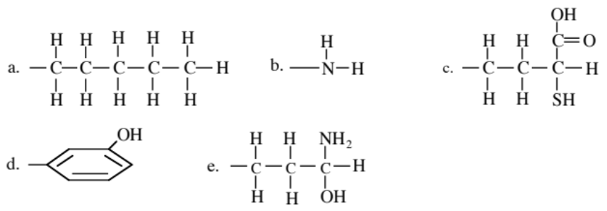

- DNA is isolated from two different species. Both DNA samples are found to be the same size. One of the DNA samples has a G+C/A+T ratio of 2.0 and the other 2.5. Which sample contains the smallest number of H bonds between strands? Which DNA sample would be easiest to denature?

- What are two main factors determining the strength of electrostatic interactions for bond formation in biomolecules?

- Rank the bond strengths in an aqueous environment ionic, nonpolar covalent, polar covalent, hydrogen, van der Waals (there can be ties).

- Why might hydrogen bonds be used between nitrogenous base pairs in DNA or RNA rather than covalent bonds?

- Which class of macromolecules that we have discussed would be most affected by a phosphorus deficiency?

- Protein side chains each have their own acid dissociation constant, pKa. The pKa for Arginine is 12.0. At pH = 7.0 (near physiological), will Arginine be positively or negatively charged? Why?

- Consider an enzyme that is able to break down glycosidic bonds in glycogen but not cellulose. Why might this occur?

- How are phospholipids oriented in the cell membrane? What would be the consequence of adding a hydroxyl group to the tail of the phospholipids?

- Manipulation of a side chain’s charge can be important for segregating proteins and also determining their structure. How might you change the charge of a side chain?

- Which amino acid forms covalent bonds with other amino acids of the same type?

- What type or types of bonds stabilize protein secondary structures?

- Mammalian phospholipase C is a complex enzyme composed of 4 parts. What is the general name for these parts, and why are they useful for protein production?

- The pKa of aspartic acid’s (Asp) side chain is 3.8. If the ratio of [Asp]/[Asp-] = .001, what is the pH of the solution in which the protein resides?
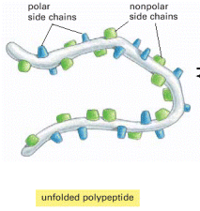
- In an aqueous solution, such as the cell cytoplasm, how would you expect the side chains shown to the right to be oriented? Why? How would this change, if at all, if the protein were placed in alcohol or oil?

- What method or methods might you employ if you wanted to isolate a protein with a known function or target?

- What method or methods might you employ if you wanted to determine which proteins are present in a given sample?

- You want to obtain a high spatial resolution structure for a dopamine receptor in the cell membrane in both the bound and unbound states. Describe which techniques you would use to do this.

- How does raising the temperature make reactions more likely to occur (i.e. more energetically favorable)?

- X-ray crystallographic reconstructions of structures from protein samples embedded in two different solutions and then frozen show two very different conformations. What properties might differ between the two solutions? (This is a general question with multiple potential answers).

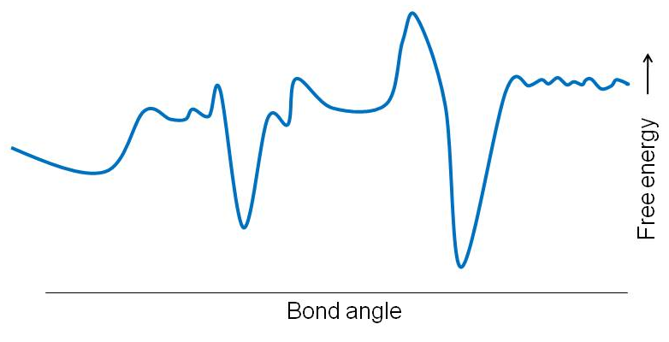
- On the right is a plot of free energy changes (positive is up) versus bond angle for a bond angle in protein. Mark which regions would be stable bond angles and justify your answer.

- Given the following amino acid sequence (P-I-G-S-T-Y) which portion of the sequence would most likely be embedded in the membrane and why? (Note that the amino acid list with side chains will be provided for the exam)

- In the figure below - Resolution is the ability to distinguish two separate objects as being separate. The resolution distance is the minimum distance separating two objects that still allows them to be distinguished as separate objects. What are the approximate limits of resolution of the human eye, the light microscope and the electron microscope?

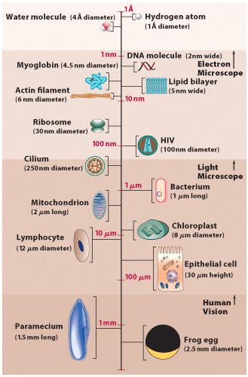

- You treat a partially purified preparation of protein with a reagent that breaks bonds between sulfur atoms. Which level(s) of protein structure are likely to be affected the most?

- Which of the following tripeptides would be most likely to be soluble in an organic (hydrophobic) solvent like benzene:
N - phenylalanine - alanine - glutamine – C
N - leucine - alanine - lysine - C
N - proline - phenylalanine - leucine – C
N - arginine - lysine - proline – C
N - glutamate - aspartate - glycine - C

Explain your answer.

- Draw a 2D free energy contour plot comparing two bond angles between connected atoms in a protein. Label the axes as well as labeling the most stable regions of the diagram. Then do the same thing using a one dimensional free energy diagram with one fixed bond angle, and label the most probable angles in the diagram. Note that although we’ve bond angle in our examples, the same ideas apply to bond rotation and distance between atoms.

- Draw a hydropathy plot for a hypothetical protein, label the axes, and indicate regions that are likely to be associated with the cytoplasm or extracellular space. Redraw the plot if 6 phenylalanines were added to the N-terminus (usually how the protein is ordered for counting the amino acids) and 6 arginines were added to the C-terminus.

- What characterizes the amino acid sequences that chaperones typically bind?

- What is a consequence of protein misfolding?

- Name an advantage of having molecular chaperones.

